Results and Discussion
The primary objective of this study was to develop an advanced framework for fault diagnosis in milling machines using AE signals. By leveraging hybrid techniques that integrate time-frequency domain representations, transfer learning, and dimensionality reduction, this work aimed to overcome the challenges of traditional fault classification methods. Key metrics analyzed include F1-score, precision, recall, accuracy, and inference time. The mathematical expressions for these metrics are detailed below:
$$Accuracy= \frac{(TP+TN)}{(TP+TN+FP+FN)} ×100\%$$
$$Precision= \frac{TP}{TP+FP} ×100\%$$
$$Recall= \frac{TP}{TP+FN} ×100\%$$
$$F1-Score= 2 . \frac{ Precision ×Recall}{Precision + Recall}$$

True Positives (TP) refer to instances where the model correctly identifies faulty conditions, while True Negatives (TN) represent cases where non-faulty conditions are accurately classified. False Positives (FP) occur when non-faulty instances are incorrectly classified as faulty, and False Negatives (FN) arise when the model fails to detect faulty conditions, classifying them as non-faulty. Together, these metrics offer a thorough assessment of the model's classification capabilities.
To validate its effectiveness the proposed method was compared with two reference approaches: a deep learning-based model using ResNet50 and DenseNet121 (DLMethod) and a traditional machine learning approach (TradML) based on handcrafted feature extraction followed by classification. This section presents the classification results, discusses comparative performance, and highlights critical observations and practical implications. The performance of the proposed model was evaluated using a comprehensive dataset consisting of seven distinct classes N, NI, TF, BF, BFI, GF, and GFI. The proposed method achieved exceptional classification performance across all evaluation metrics, with 100% F1-score, precision, recall, and accuracy. This signifies perfect identification and classification of all classes, demonstrating the strength and reliability of the proposed hybrid framework. Additionally, the inference time for the proposed method was recorded at just 0.04 milliseconds per sample, making it highly efficient for real-time applications. In comparison, the DL-Method achieved an F1-score, precision, recall, and accuracy of 98%, with an inference time of 0.1 milliseconds per sample. While this performance is commendable, it falls slightly short of the proposed method due to its inability to effectively handle overlapping feature spaces for complex fault classes. The TradML approach performed noticeably worse, achieving an F1-score, precision, recall, and accuracy of 93%, with an inference time of 0.09 milliseconds per sample. The lower performance of this method is attributed to its reliance on handcrafted features, which may lack the granularity and discriminative features required for accurate fault classification in complex and noisy datasets. A summary of these results is provided in Table X for comparison.
Table 1. Performance comparison of the proposed method
Model | F1-Score (%) | Precision (%) | Recall (%) | Accuracy (%) | Inference Time ($ms/sample$)
Proposed | 100 | 100 | 100 | 100 | 0.04
DLMethod | 98 | 98 | 98 | 98 | 0.1
TradML | 0.93 | 0.94 | 0.93 | 0.93 | 0.09
The proposed method significantly outperforms the two reference models across all performance metrics. The DL-Method, while employing robust architectures like ResNet50 and DenseNet121, is limited by its inability to fully optimize features across multiple domains. The lack of a dimensionality reduction step, such as UMAP, further constrains its ability to manage high-dimensional feature spaces, leading to reduced accuracy and increased inference time. On the other hand, the TradML approach, which depends on manually engineered features, struggles with capturing the complex, non-linear patterns present in AE signals, resulting in inferior classification performance. The superior performance of the proposed method can be attributed to its hybrid framework, which combines CWT scalograms and STFT spectrograms for comprehensive time-frequency analysis. By utilizing pre-trained architectures for feature extraction and UMAP for dimensionality reduction, the proposed method ensures the retention of critical information while minimizing redundancy. The use of k-NN for classification further enhances its performance, offering a simple yet effective approach for distinguishing between all classes.
The performance comparison across different fault classes is visualized in Figure X, highlighting the superior classification capabilities of the proposed method over the two reference models. The proposed method achieved perfect classification performance, with 100% accuracy, F1-score, precision, and recall across all fault classes, as evident from the uniformly high bar heights for each fault condition. This demonstrates its robustness and reliability in handling complex and overlapping features in acoustic emission signals. The consistent performance of the proposed method also underscores its scalability and applicability for real-time industrial fault detection.
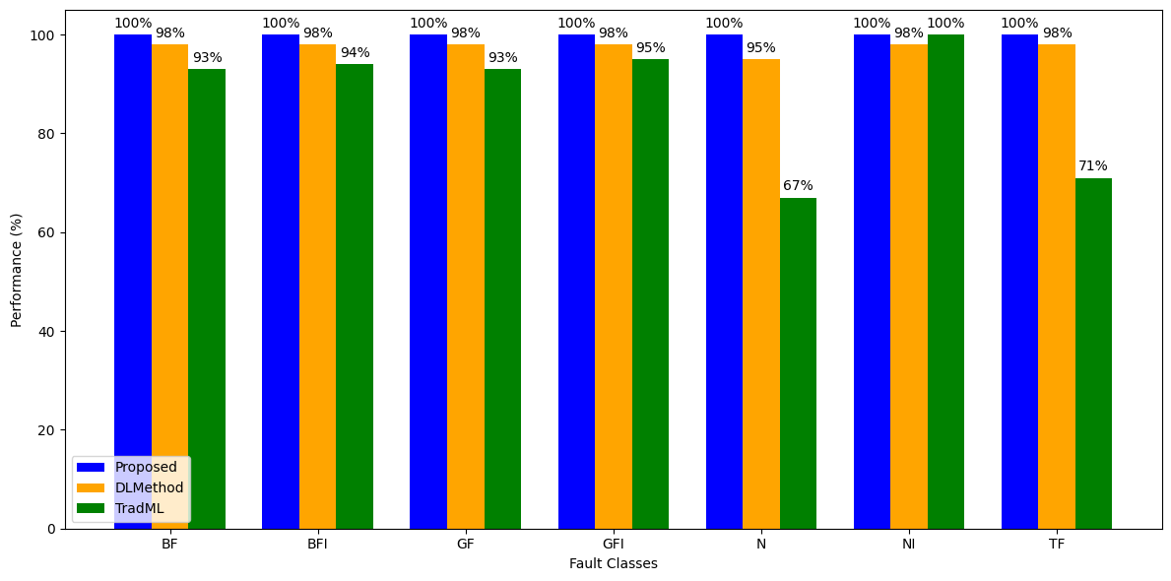
Figure 1. Performance comparison chart for each class of the milling machine.
To illustrate the effectiveness of the proposed method, t-SNE plots and confusion matrices were generated. The t-SNE plot for the proposed method as in Figure 1 shows clear and distinct clusters for each fault class, indicating excellent separability and minimal overlap between classes. This highlights the ability of the proposed method to effectively capture and represent discriminative features in a reduced dimensional space. In contrast, the t-SNE plots for the DL-Method and TradML approaches reveal significant class overlap, particularly for closely related fault types. This overlap indicates that these methods struggle to separate fault classes with similar characteristics, leading to misclassifications. The confusion matrix for the proposed method as shown in Figure 2 shows no misclassifications, with all samples correctly identified across all classes. In comparison, the confusion matrices for the DL-Method and TradML approaches reveal several misclassifications, particularly for fault classes with overlapping features, further emphasizing the superiority of the proposed method.
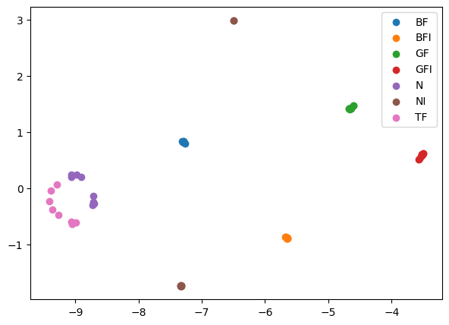  (a) | 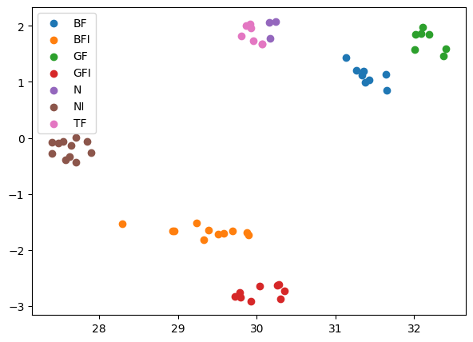  (b) | 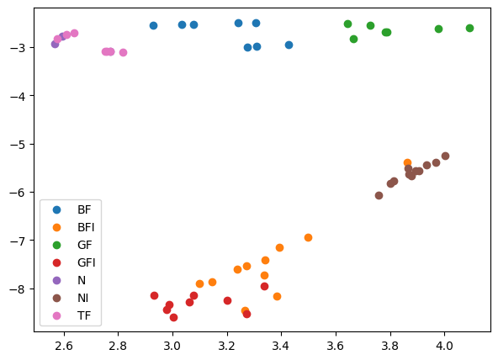  (c)
Figure 2. Visualization of t-SNE plots: (a) The proposed model; (b) DLMethod; (c) TradML.
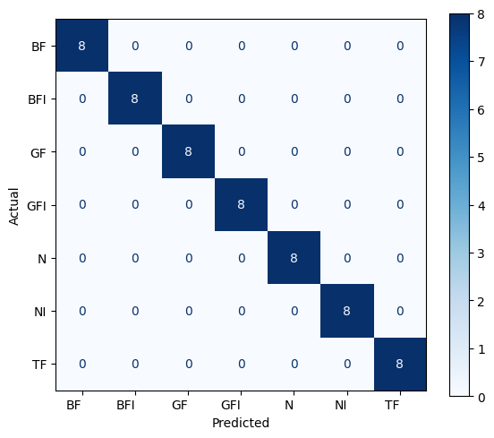  (a) | 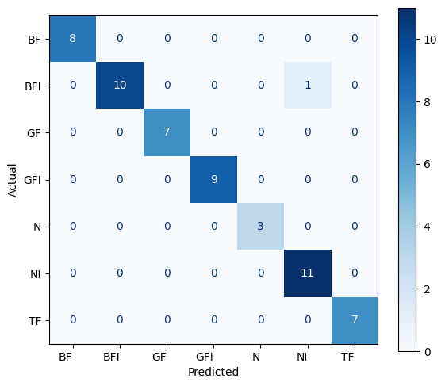  (b) | 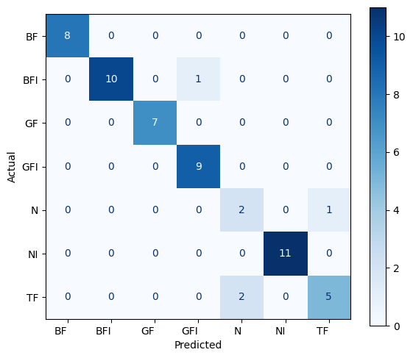  (c)
Figure 3. Visualization of confusion matrices plots: (a) The proposed model; (b) DLMethod; (c) TradML.
The proposed method's success can be attributed to several key factors. First, the combination of CWT and STFT ensures a comprehensive representation of AE signals, capturing both localized transient phenomena and global spectral changes. This dual representation is particularly effective for diagnosing complex fault conditions. Second, the use of transfer learning enables the extraction of powerful, high-level features from the scalograms and spectrograms. Third, the application of UMAP for dimensionality reduction addresses the challenges associated with high-dimensional data, ensuring computational efficiency without compromising feature integrity. By reducing the dimensionality of the feature space, UMAP enhances the performance, enabling accurate and efficient classification. Lastly, the simplicity and strength of the k-NN algorithm ensure that the proposed method is not only accurate but also computationally efficient, making it suitable for real-time applications.
The proposed method offers significant potential for real-world applications in milling machine fault diagnosis. Its high accuracy and low inference time make it well-suited for real-time monitoring and predictive maintenance, enabling manufacturers to detect and address faults before they lead to machine downtime or costly repairs. Furthermore, the scalability of the proposed framework ensures its applicability to other industrial systems, providing a versatile solution for fault diagnosis across various domains.

